1.0 Scope |  |  |  | 2.0 Resource Required
1.1 Purpose: Quality-compliant packing of annealed glass using end caps for direct dispatch  1.2 Area of Application: All annealed packing station  1.3 Responsibility: Shift Packing Officer  1.4 Accountability: Section head & Production head |  |  |  | 2.1 Man: Shift Packing Officer, Glass lifter, Packer  2.2 Machine: Strapping machine  2.3 Material: Special L-Rack, wooden end cap, silica gel, EVA rubber, LDPE, 32 mm plastic straps, jolly board, EVA foam.
3.0 Terms and Definition |  |  |  | 4.0 Key Performance Requirements
3.1 End Cap: It is wooden frame, which is used for packing the annealed glass |  |  |  | 4.1 Quality: Scratch free stacking of good glass on rack with desired quantity  - EHS: No cut injury or ergonomic incident
5.0 Frequency |  |  |  | 6.0 Competency Enhancement
5.1 For each glass produced in annealed line |  |  |  | 6.1 Training on Glass lifting & robot to be given to all shift officers & Contract workers.  6.2 Visual posters are to be used for Do’s & Don’ts & communication.
7.0 Procedure
7.1 Sequence of Operation

7.1.1 Rack & end cap preparation:  - Place the L-Rack for work in progress (WIP) packing.  - Bind two Jolly Boards (25mm) on each vertical metallic plank for additional support as shown in Figure-01  - Ensure that the wooden end caps are in good condition without any transportation damage, knots, bends, holes, or crack & change the EVA rubber of the end caps (if required). Parts are listed below in figure-02/03/04.  *Reject any defective end caps and keep them separately.  - Place a wooden bottom end cap evenly on the bottom support of the L-Rack. Ensuring the center align. |  |  |  |  | 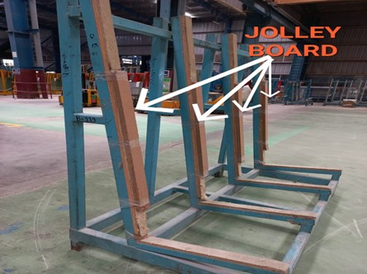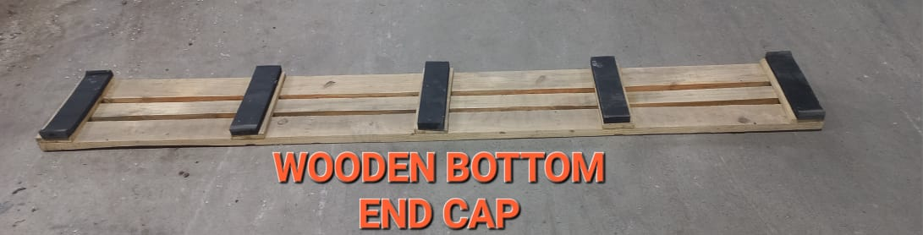  Figure-01  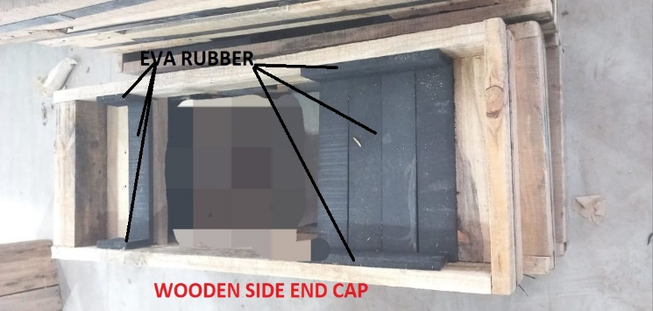  Figure-03  Figure-02  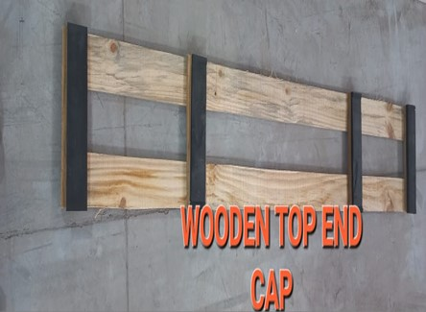  Figure-04
- Glass placing on the end cap.  - Stack the first glass sheet on the bottom end cap, ensuring the following:  There is no gap between the glass and the vertical support of the L-Rack (Figure-05)  Both corners of the glass sheet should not rest on the EVA rubber. (Figure-06)  - The glass sheet should be stacked evenly on the bottom end cap. (Figure-07)  - Continue stacking the glass following the Work instruction PRD/L3/001.  - Stack only specified quantity of the glass sheets according to the size and stacking pattern as mentioned in the table below. |  |  |  |  | 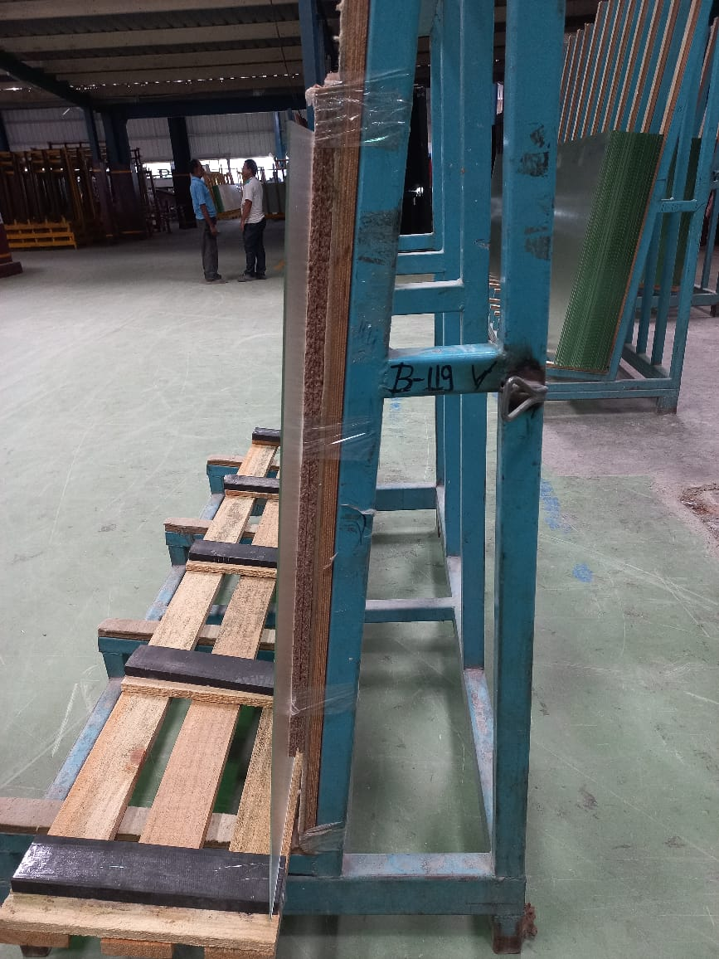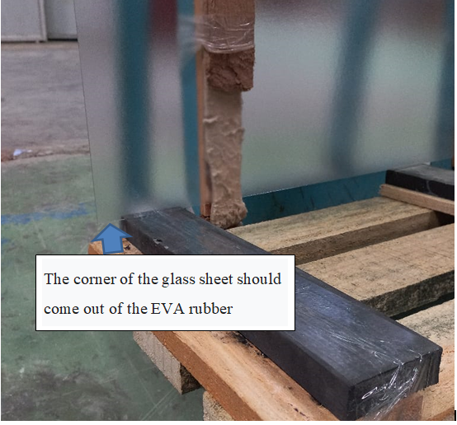  Figure-05  Figure-05  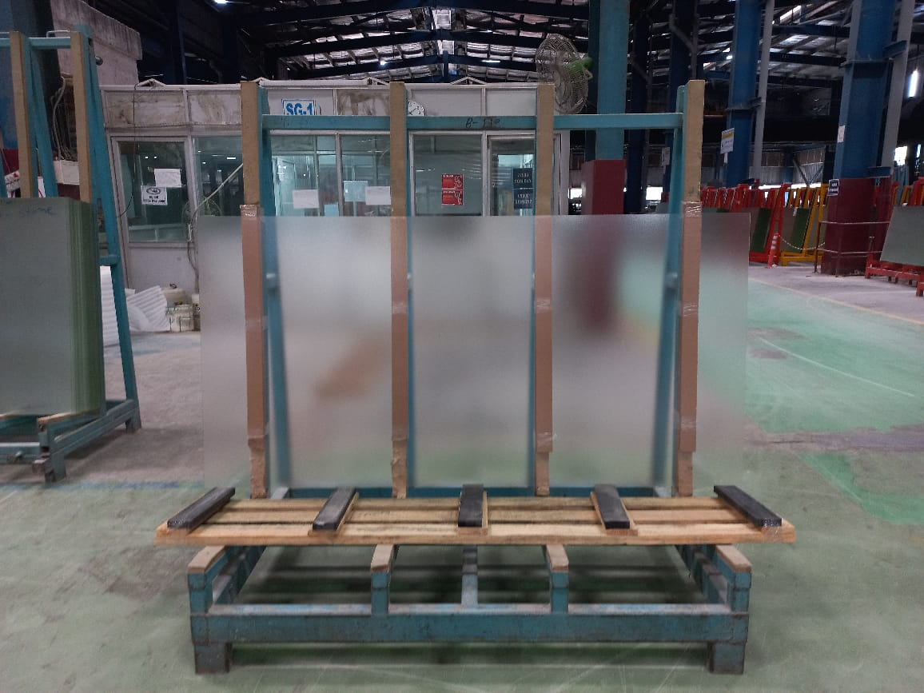  Figure-06
    - Stacking quantity: Stack only specified quantity of the glass sheets according to the size and stacking pattern as mentioned in the table below.
For M-10 Series (2200 series glass)
Sl.no | Size (mm) | Stacking Pattern | No. of Pieces in Stack | Glass Weight (KGS)
1 | 2273 X 1129 X 3.2 mm | Vertical | 80 | 1612
2 | 2273 X 1129 X 2.8 mm | Vertical | 90 | 1586
3 | 2273 X 1129 X 2.5 mm | Vertical | 100 | 1574
4 | 2273 X 1129 X 2.1 mm | Vertical | 120 | 1586

For 1900 Series
Sl.no | Size (mm) | Stacking Pattern | No. of Pieces in Stack | Glass Weight (KGS)
1 | 1981 x 996 X 3.2 mm | Vertical | 105 | 1626
2 | 1981 x 996 X 3.2 mm | Vertical | 120 | 1626
3 | 1981 x 996 X 3.2 mm | Vertical | 130 | 1573
4 | 1981 x 996 X 3.2 mm | Vertical | 150 | 1525

For 1700 series
Sl.no | Size (mm) | Stacking Pattern | No. of Pieces in Stack | Glass Weight (KGS)
1 | 1717 x 1036 x 2.1 mm | Vertical | 180 | 1650

7.1.3 Pre-Packing inspection:  - Once the stacking is done as per the quantity, inspect the stacked glass using torch for breakage, chipping, alignment and protruding glass.  *Ensure the lite count quantity of the pile must be the same as defined in order. |  |  |  |  | 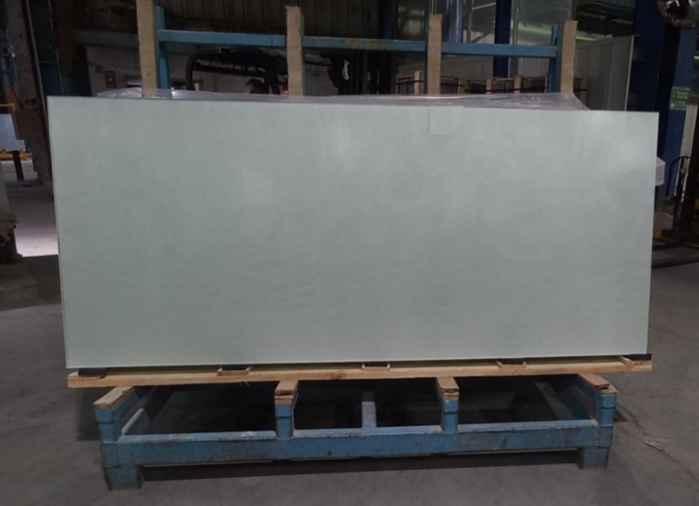
7.1.4 Packing of the piles:  - In inspected ok pile, place the barcode inside the glass pile as shown in Figure-09  - Cover the both upper corners of the glass pile using the EVA foam as shown in Figure-10  - Place four silica gel packets on the top side and four silica gel packets on the bottom side of the pile to prevent moisture. (as shown in Figure-11)  - Cover the entire pile with plastic (LDPE) which will help to protect the glass from dust and moisture. (as shown in Figure-11)  - Place the Top end cap on the glass pile above the pile ensuring the alignment with glass.  - Insert the left and right-side end cap from both sides of the pile. |  |  |  |  | 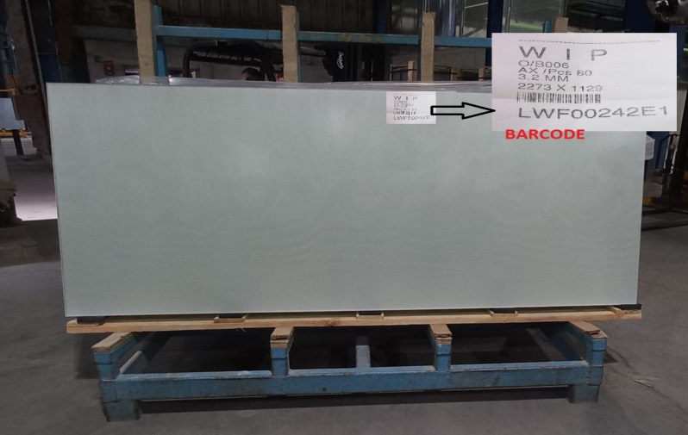  Figure-09  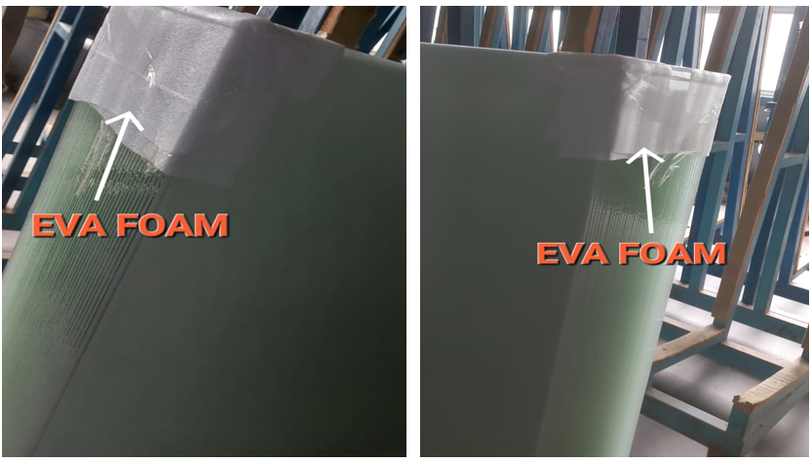  Figure-10  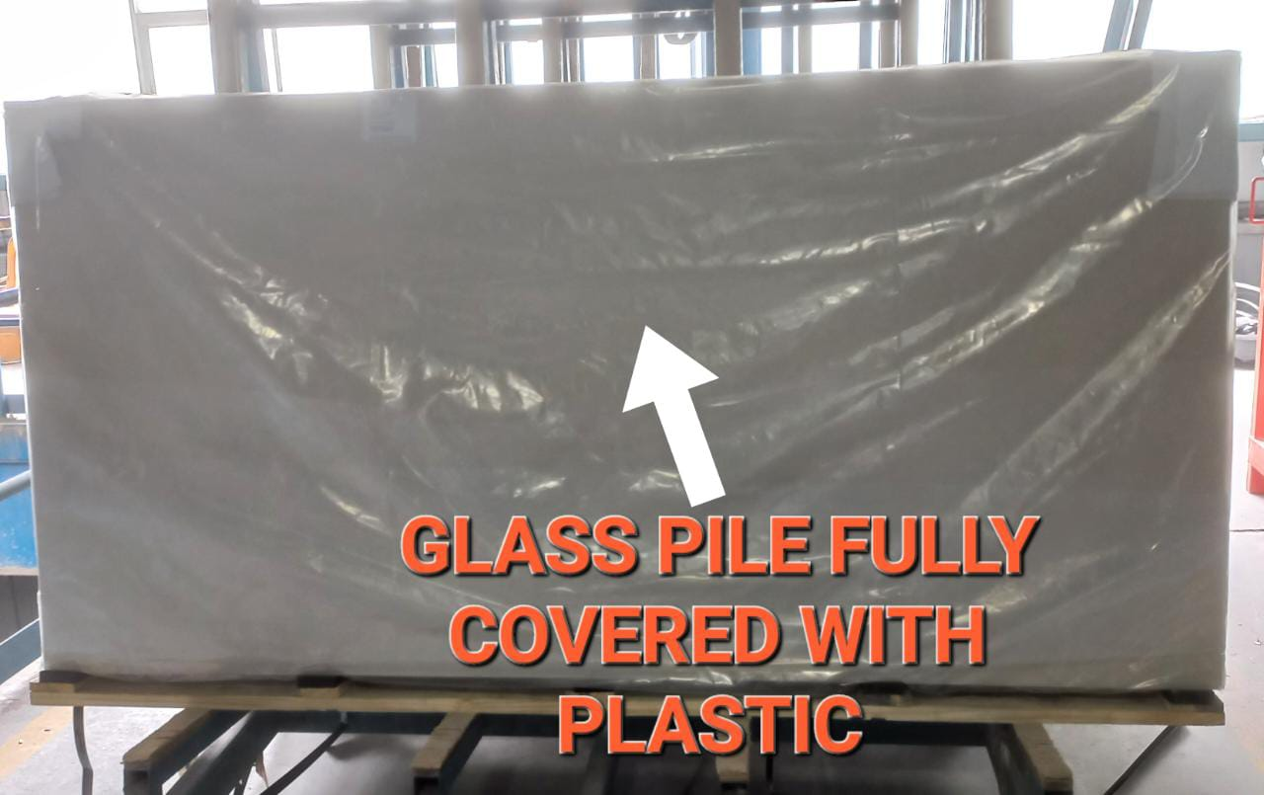  Figure-11
- Strapping:  - Strapping should be done on both edges of the pile including side end cap and top & bottom cap as shown in Figure-12(A) and at center area covering top and bottom end cap as shown in Figure-12(B).  - Two horizontal strappings should be done covering both side end caps as shown in Figure-12(C).  - Tighten the strapping using the strapping machine.  - Lock the strapping. |  |  |  |  | 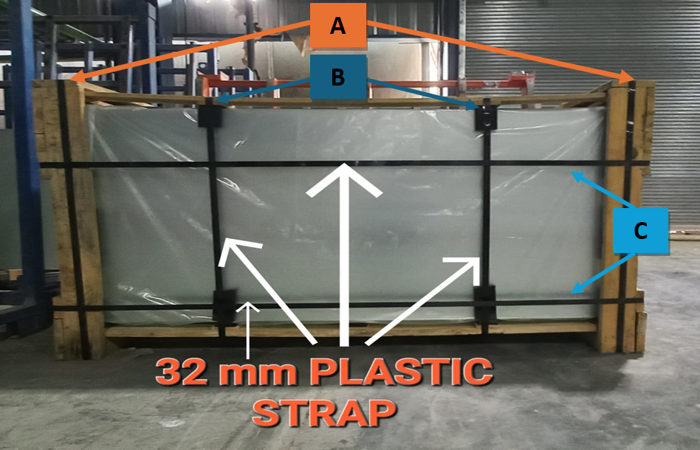  Figure-12
    - Barcode & Record:
- After completing the packing, past the barcode on both sides of Endcap packing
Note: Ensure the barcode should be exactly same as pasted inside the pile.
- Record the packed Endcap pile data in WIP packing register.
- OK pieces, rejection pieces and problems need to be recorded in sheet.

7.2 Special Process Requirements
Not applicable

7.3 Prevention & Detection Controls
7.3.1 If any chipping or cutting issue observed continuously, inform the cutting in charge for correction

7.4 Controls Related to EHS
7.4.1 PPE MATRIX
 |  |  |  |  |  |  | 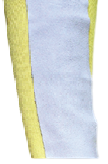
Goggles | Safety shoes |  | Hand Gloves |  |  |  | Arm Guard
7.4.2 All broken glasses need to collect in cullet bin and dispose of it to main crusher
8.0 EHS Compliance Obligations
8.1 Not applicable
9.0 Possible deviation & Impacts |  |  |  |  |  | 10. Proposed actions
9.1 Improper stacking alignment of glass can lead to breakage.  9.2 Defected glass kept with OK glass may lead to customer complaint  9.3 Overtighten or lose strapping can lead to breakage in glass |  |  |  |  |  | 10.1 Stack the glass on rack with proper alignment.  10.2 Defective glass and OK glass should be kept on identified racks separately  10.3 Strapping should be done by trained person only
11. Reference documented information
11.1 Barcode slip.
11.2 WIP packing register.
12. Revision History
Revision No. | Date | Description of changes
00 | 12.02.2020 | Initial release.
01 | 01.07.2023 | Picture & safety requirement added
02 | 08.07.2025 | Format standardized, revision history added, step correction done.

